
Child- Friendly Safeguarding policy 2024
In our school we respect our children and want to keep you safe and help to protect your rights.
We do our best to help you to make good progress in your school work and to be happy.
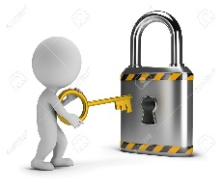 How we will try to keep you safe
- We try to provide a safe place for you to learn in
- We want to keep you safe at home as well as at school
- We think it’s important for you to know where to get help if you are scared or unhappy about something and we teach you this in PSHE or SMSC lessons
- We will use worry boxes (found in classrooms) so that children can write down any worries they have and an adult will check them regularly.
- If you need to talk – we will listen!
- We will teach you about dangers and how to keep yourselves safe
 Don’t keep it a secret if someone is 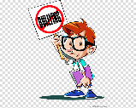
- Sending unkind messages on the internet or to your phone
- Trying to give you drugs, cigarettes or alcohol
- Trying to give you medicine when you don’t feel that you need it
- Bullying or trying to upset you
- Doing or saying things that make you feel uncomfortable
- Hurting you or touching you if you do not like it
- There is anything wrong
- Asking for your things
- Taking your things and not giving them back
All teachers will help to protect us and keep us safe so you can talk to any grown up that you trust. The safeguarding team in our school are
Miss Valentine Mr Campbell Miss Harrison Mrs Blay Mrs Cordwell
